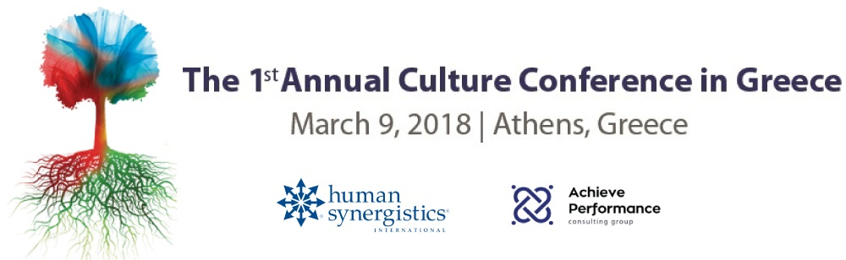

Application Form

Conference Details |  | Title: 1st Annual Culture Conference in Greece  Date: March 9, 2018  Location : Glyfada Golf Gardens
Company  Details |  | Company Name:  Industry:  Address:  Postal Code - City:  VAT Number - Tax Office:
Contact  Address |  | First Name:  Last Name :  Job Position:  Telephone Number:  Fax:  Email:
OAED Program (LAEK 0.24)  Participants |  | Yes  No  Name Job Position Ε-mail  1)  2)  3)  4)  5)  6)  7)  8)

Conference Organizer | Company Name:  Achieve Performance A.P. Group SA  Bank: National Bank of Greece  Bank Account: 669/ 001117-75  IBAN: GR5701106690000066900111775  Swift / BIC: ETHNGRAA

